Project Planning Phase
Project Planning Template (Product Backlog, Sprint Planning, Stories, Story points)

Date | 18 October 2026
Team ID | SRCUM
Project Name | Visualization Housing Market Trends
Maximum Marks | 8 Marks

Product Backlog, Sprint Schedule, and Estimation (4 Marks)
Use the below template to create product backlog and sprint schedule
Sprint | Functional Requirement (Epic) | User Story Number | User Story / Task | Story Points | Priority | Team Members
Sprint-1 | Data Preparation | VHMTAT-1 | As a user, I want the housing dataset to be cleaned and prepared for analysis. | 2 | High | Jaya Surya
Sprint-1 | KPI Dashboard | VHMTAT-2 | As a user, I want to view KPI overview (total houses, average sale price). | 1 | High | Sri Hari
Sprint-2 | Renovation Analysis | VHMTAT-3 | As a user, I want to analyze the impact of renovation on house sale prices. | 2 | High | Sri Hari
Sprint-2 | House Age Analysis | VHMTAT-4 | As a user, I want to view house age distribution by renovation status. | 2 | Medium | Jaya Surya
Sprint-3 | Feature Analysis | VHMTAT-5 | As a user, I want to compare bedrooms, bathrooms, and floors across house age groups. | 1 | Medium | Sri Hari
Sprint-3 | Dashboard Integration | VHMTAT-6 | As a user, I want all scenarios combined into a single interactive dashboard. | 2 | High | Sri Hari
Sprint-4 | Website Integration | VHMTAT-7 | As a user, I want to view the dashboard through a web application. | 2 | High | Padmaleela & Sowmya
Sprint-4 | Documentation & Testing | VHMTAT-8 | As a reviewer, I want clear documentation and a tested dashboard. | 1 | Medium | Sowmya

Project Tracker, Velocity & Burndown Chart: (4 Marks)
Sprint | Total Story Points | Duration | Sprint Start Date | Sprint End Date (Planned) | Story Points Completed (as on Planned End Date) | Sprint Release Date (Actual)
Sprint-1 | 20 | Days | 01 Feb 2026 | 03 Feb 2026 | 20 | 03 Feb 2026
Sprint-2 | 20 | 3 Days | 05 Feb 2026 | 08 Feb 2026 | 20 | 08 Feb 2026
Sprint-3 | 20 | 3 Days | 09 Feb 2026 | 12 Feb 2026 | 20 | 12 Feb 2026
Sprint-4 | 20 | 3 Days | 13 Feb 2026 | 15 Feb 2026 | 20 | 15 Feb 2026

Velocity:
Imagine we have a 10-day sprint duration, and the velocity of the team is 20 (points per sprint). Let’s calculate the team’s average velocity (AV) per iteration unit (story points per day)
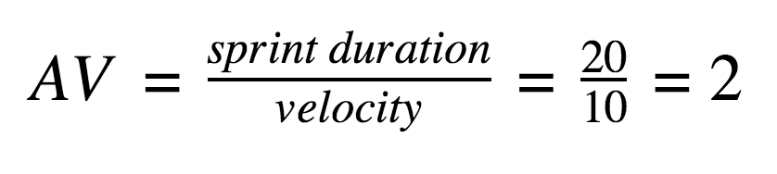
Burndown Chart:
A burn down chart is a graphical representation of work left to do versus time. It is often used in agile software development methodologies such as Scrum. However, burn down charts can be applied to any project containing measurable progress over time.

